Error: Reference source not found
–
Author: Sathiyabanu R
Date: March 26, 2024

1. Abstract 3
2. Requirements 3
2.1 Functional Requirements 3
2.2 Non-Functional Requirements 4
2.2.1 Performance 4
2.2.2 Reliability 5
2.2.3 Security 5
2.2.4 Usability 5
2.2.5 Scalability 5
2.2.6 Maintainability 5
3. Implementation 7
3.1 Flow Chart 7
3.2 Use Case Diagram 8
3.3 Class Diagram 9
3.4 Sequence Diagram 10
4. Test cases 11

Abstract
In the digital age, internet shopping platforms have evolved as critical components of retail trade, altering consumer behaviour and market dynamics. This abstract falls into the many goals and functions of online shopping platforms. It discusses how these systems aim to provide a seamless shopping experience, encompassing aspects such as convenience, accessibility, efficiency, security, and customer satisfaction. It looks at how these systems try to provide consumers with exceptional convenience, accessibility, and efficiency, allowing them to browse, choose, and purchase products or services with ease. It investigates the critical role of security measures in preserving client data and transactions. It highlights the transformative impact of online shopping systems on the retail landscape, as well as their ongoing significance in modern commerce, through a detailed analysis.
A simplified checkout experience, supported by several payment gateways and shipping options, improves customer convenience and flexibility. Furthermore, interaction with third-party logistics providers enables quick order fulfillment and shipment tracking, promoting transparency and accountability throughout the delivery process.

Requirements
2.1 Functional Requirements
1. Administrator:
- Database Management: Control the database and keep track of all customers and employee information.
- View all details: View the details of all employees and control the whole site.
- Advertising the Site: Responsible for making advertisements for the site.

- Customers:
- Login: Customers must have a valid login id to enter into the site.
- Registration: New users can sign up by creating new ID.
- View and edit Own Details: Can view/edit his personal details, payment details, and details about services provided.
- Choosing and comparing products: Can view all available products and can compare them and make a choice for purchasing products.
- Purchasing: Can purchase any product through valid credit card.
- Giving Feedback to Customer Care: Can provide feedback to the 24x7 Customer Care Service center regarding their impressions of the site and services.
- Logout: Customer must logout of the site after purchasing products.

- Visitors:
- Visiting the Site: Can only visit the site without registration.
- Register

- Shop Owner:
- Taking Permission from Administrator: Retailers have to get approval from the Administrator before selling their products through the website. The administrator will assess the quality of the goods in relation to its market price before allowing the buyer to sell it.
- Consulting with Administrator: Can consult with the Administrator regarding product's quality and advertisements.

- Sales Manager:
- View customer details: View the personal details of the customer.
- Managing Sales to Customers: Responsible for properly assigning the selected product based on the customer's preferences and delivering it to the customer.
- View Product Stocks: Keep track of each product item's stocks for selling purpose.
- Contacting with Administrator: Responsible for informing administrator when any product item's stock goes under the minimum level.

- Purchase Manager:
- Consulting with Administrator: Taking permission from the Administrator for the product to be purchased from vendor.
- Product Stock Management: Responsible for managing stocks of each product items.

- Account Manager:
- Regulating Payments: Keep track of all the payment transactions made by the customers and update the payment information.
- Consulting with Banks: Responsible for contacting banks to validate the account number provided by the consumer throughout the purchase process and conducting the transaction from the provided account.
- Consulting with Administrator: Consult with the Administrator about the payment details of the customers for the updating of the database.

  - Non-Functional Requirements

    - Performance

- Response Time
- The system should respond to user interactions within 2 seconds during normal load levels.

- Throughput
- The system must support at least 1000 transactions per minute during peak usage periods.

- Scalability
- The system architecture should scale horizontally to accommodate increased loads without compromising performance.

    - Reliability

- Availability
- The system must have a minimum uptime of 99.99% each month, excluding scheduled maintenance.

- Fault Tolerance
- The system must function properly even with hardware or software problems.

- Data Integrity
- Logging and verifying all data transactions ensures correctness and prevents corruption.

- Backup and Recovery
- Regular backups of system data are required, with systems in place for quick recovery in event of failure.

    - Security

- Authentication and Authorization
- Users must authenticate securely before accessing sensitive information or executing transactions.

- Data Encryption
- Sensitive data such as user credentials and payment information shall be encrypted during transmission and storage.

- Secure Payments
- Payment processing must adhere to PCI DSS requirements to prevent fraud and maintain financial privacy.

    - Usability

- User Interface
- The user interface shall be intuitive, user-friendly, and consistent across different devices and platforms.

- Accessibility
- The system must meet WCAG criteria to provide accessibility for people with disabilities.

- Responsiveness
- The system shall provide real-time feedback to user actions to enhance the user experience.

    - Scalability

- Growth Accommodation
- The system architecture should be flexible enough to grow with customers and material without requiring extensive re-engineering.

    - Maintainability

- Modularity
- The system shall be designed with modular components to facilitate easier maintenance and updates.

- Documentation
- Provide comprehensive documentation for system components, APIs, and procedures to facilitate maintenance and monitoring.

Implementation

Flow Chart
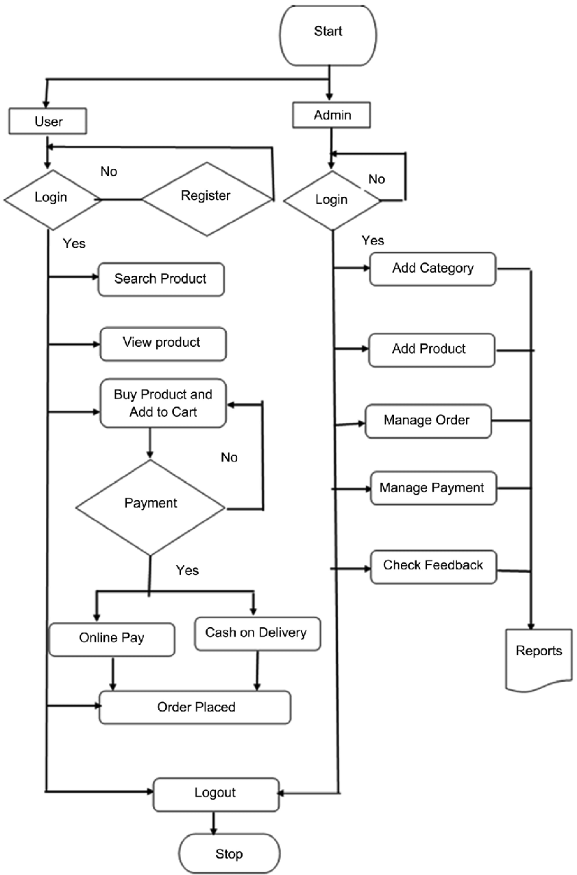
Figure 3.1.1 Flow Chart

Use Case Diagram
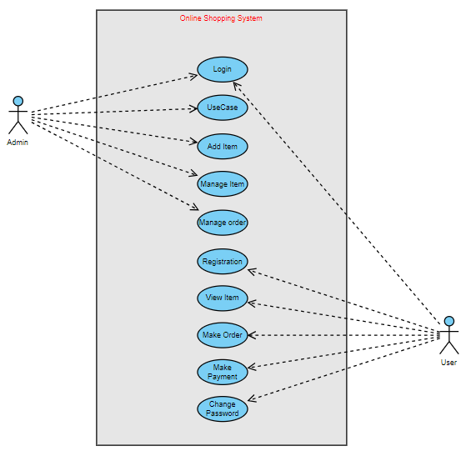
Figure 3.2.1 Use Case Diagram

Class Diagram
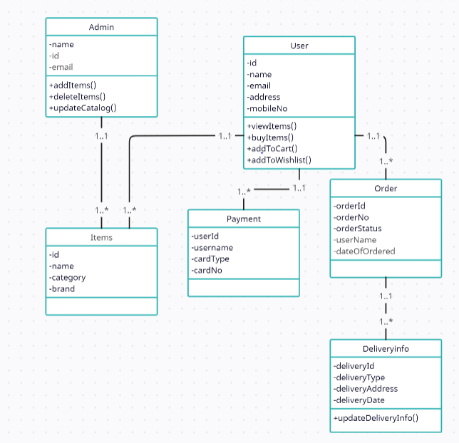
Figure 3.3.1 Class Diagram

Sequence Diagram
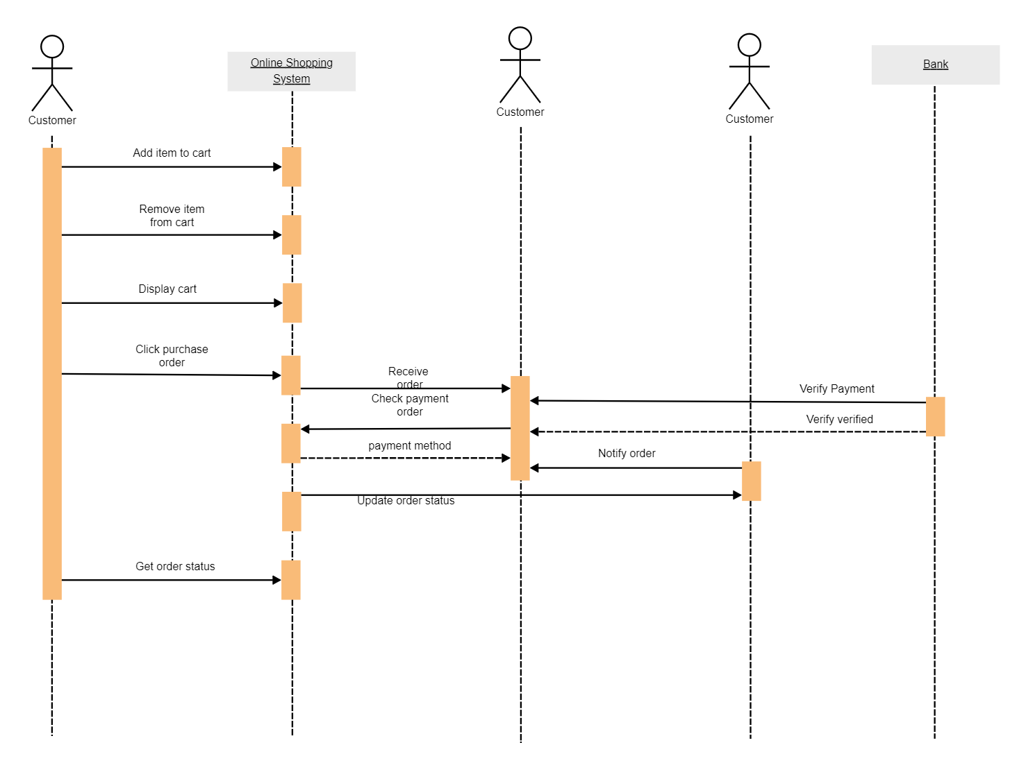
Figure 3.4.1 Sequence Diagram

Test cases
- Test case 1: Verify that a new user can successfully register with valid details (name, email, password).
- Test case 2: Verify that registration fails if the user enters invalid or incomplete information.
- Test case 3: Verify that the system prevents duplicate registration with the same email address.
- Test case 4: Verify that users can search for products by entering keywords in the search bar.
- Test case 5: Verify that users can filter products by category, price range, brand, etc., and the results are accurate.
- Test case 6: Verify that the search and filter functionalities work correctly even with a large number of products.
- Test case 7: Verify that users can add products to their cart from the product details page.
- Test case 8: Verify that the cart updates dynamically when products are added or removed.
- Test case 9: Verify that users can update the quantity of products in the cart.
- Test case 10: Verify that users can proceed to checkout and enter shipping details.
- Test case 11: Verify that users can select a payment method and complete the checkout process successfully.
- Test case 12: Verify that the system calculates the order total correctly, including taxes and shipping charges.
- Test case 13: Verify that users can view their order history and track the status of their orders.
- Test case 14: Verify that admins can view all orders, update order status (processing, shipped, delivered), and generate invoices.
- Test case 15: Verify that users receive order confirmation emails with the correct order details.
- Test case 16: Verify that the system handles payment failures gracefully and provides appropriate error messages.
- Test case 17: Verify that payment confirmation emails are sent to users after successful transactions.
- Test case 18: Verify that user passwords are stored securely (hashed and salted) in the database.

